**Write a program to implement a Stack using two Queues**

#include <stdio.h> #include<conio.h>

#define N 20

//declaring two queues and there fron and rear variables int queue1[N],queue2[N]; int f1= -1, r1= -1; int f2= -1, r2= -1; int count=0;

//declaring two queues operations void enqueue1(int x); int dequeue1(); void enqueue2(int x); int dequeue2();

//declaring stack operations void push(int x); int pop(); void display(); //main function void main()

{ //declaring local variable

int ch, num; clrscr(); while (ch != 4) { //input user choice printf("\n1.Push Item\n2.Pop Item\n3.Display Item\n4.Exit\n"); printf("\nEnter your choice :"); scanf("%d", &ch); switch (ch)

{

case 1: printf("Entre item to be inserted : "); scanf("%d", &num); push(num); //insert function call

break;

case 2: printf("Item deleted : %d",pop()); //delete function call

break;

case 3: display(); //printing stack elements

break;

case 4: exit(0);

break; //exit

default:printf("\nInvalide Choice !!!\n"); //invalid input

}

}

}

//enqueue operation for queue 1 void enqueue1(int x)

{

if(r1==N-1)

{

printf("Overflow");

}

else

{

if(f1== -1)

{

f1=0;

}

r1=r1+1; queue1[r1]=x; }

}

//dequeue operation for queue 1 int dequeue1()

{

int temp;

if(f1== -1 || f1 > r1)

{

printf("underflow");

}

else

{

temp = queue1[f1]; f1++;

}

return(temp);

}

//enqueue operation for queue 2 void enqueue2(int x)

{

if(r2==N-1)

{

|  |  |
| --- | --- |
| } else { | printf("Overflow"); |
|  | if(f2== -1) |
|  | { |
|  | f2=0; |
|  | } |

r2=r2+1; queue2[r2]=x;

}

}

//dequeue operation for queue 2 int dequeue2()

{

int temp;

if(f2== -1 || f2 > r2)

{

printf("Underflow");

}

else

{

temp = queue2[f2]; f2++;

}

return(temp);

}

// push functon to insert data into stack of two Queues

void push(int x)

{

int i; enqueue1(x);

for (i = 0; i < count ; i++)

{

enqueue1(dequeue2());

}

count++;

for(i=0; i<count;i++)

{

enqueue2(dequeue1());

}

}

// pop function to delete data from stack of two Queues int pop()

{

count--; return dequeue2();

}

// displaying the data of stack of two Queue void display()

{

int i; printf("\nElements in Stack : "); for (i = f2; i <=r2 ; i++)

{

printf("%d ", queue2[i]);

}

printf("\n");

}

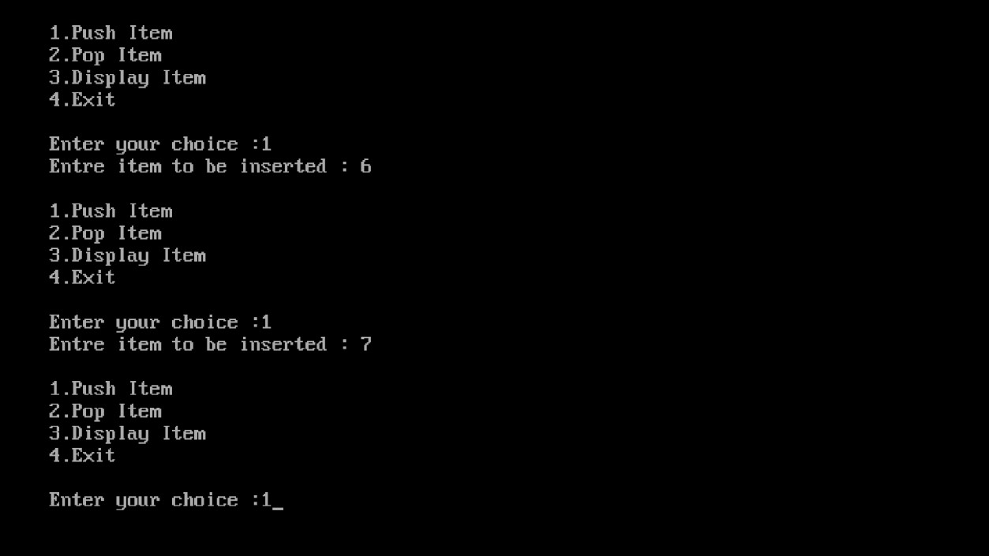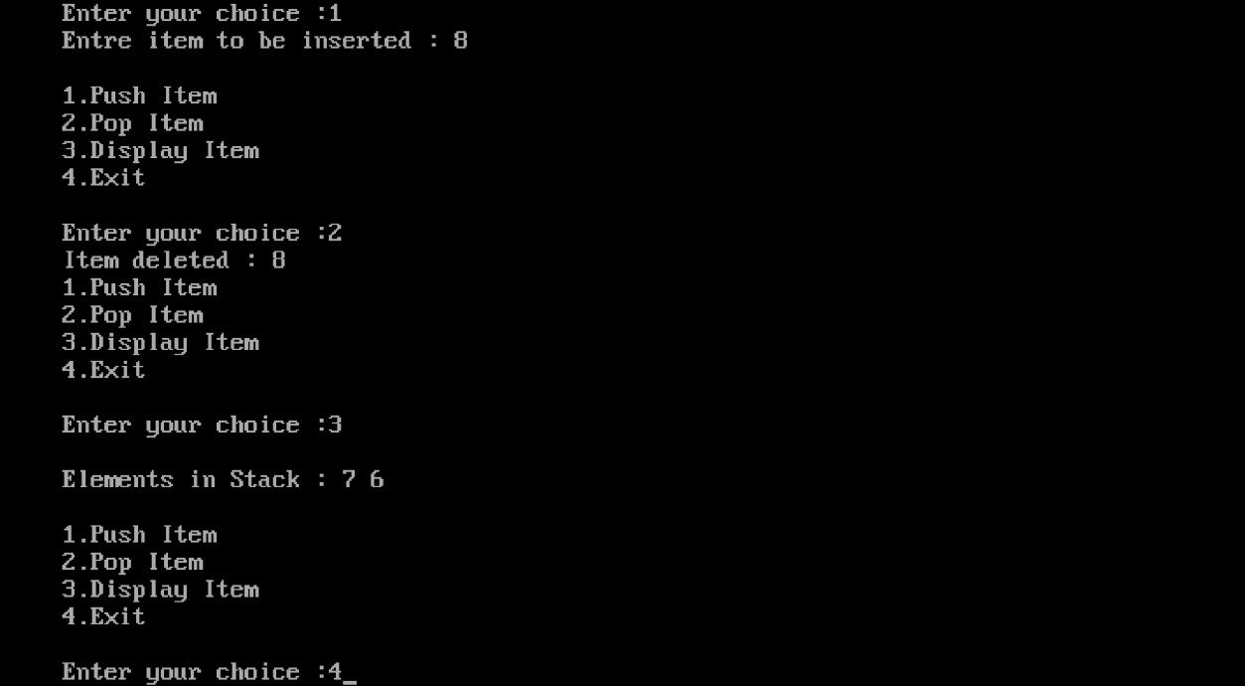

**Write a program to implement a Queue using two stacks.**

#include<stdio.h>

#include<stdlib.h>

#define N 10

int s1[N],s2[N]; int top1=-1; int top2=-1;

int count=0;

void enqueue(int x); void deque(); void push1(int x); void push2(int x); int pop1(); int pop2();

void display();

void main() { int ch,x; while(1) {

printf("\n 1. Insert"); printf("\n 2. Delete"); printf("\n 3. Display"); printf("\n 4. Exit"); printf("\n Enter your choice: "); scanf("%d", &ch); switch(ch) {

case 1: printf("\n enter the number: ");

scanf("%d", &x);

enqueue(x);

break;

case 2: deque();

break;

case 3: display(); break;

case 4: exit(0);

default: printf("wrong choice");

}

}

}

void enqueue(int x) { push1(x); count++;

}

void push1(int x) { if(top1 == N-1) {

printf("\n stack is full");

} else { top1++; s1[top1]=x;

}

}

void push2(int x) { if(top2 == N-1) {

printf("\n stack is full");

} else { top2++; s2[top2]=x;

}

}

int pop1() { return(s1[top1--]);

}

int pop2() { return(s2[top2--]);

}

void deque() { int i,a,b;

if(top1 == -1 && top2 == -1)

{

|  |  |
| --- | --- |
| } else { | printf("\n stack is empty"); |
|  | for(i=0;i<count;i++) |
|  | { |
|  | a=pop1(); |
|  | push2(a); |
|  | } |
|  | b=pop2(); |
|  | printf("\n deleted element is : %d", b); |
|  | count--; |
|  | for(i=0;i<count;i++) |
|  | { |
|  | a=pop2(); |
|  | push1(a); |
| }  } | } |

void display() { int i; for(i=0;i<=top1;i++) {

printf(" %d ",s1[i]);

}

}

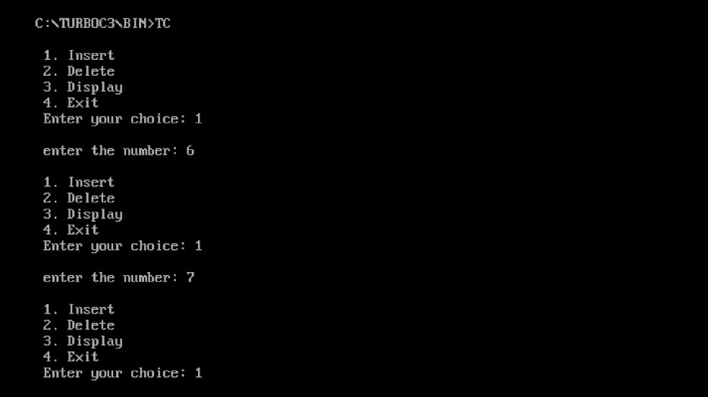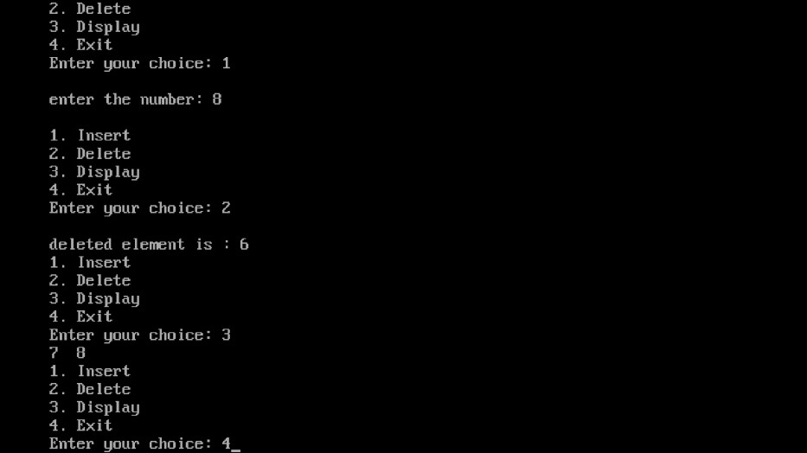

Write programs to implement the following data structures: (a) Single Linked list

#include <stdio.h> #include <stdlib.h> struct Node

{ int data; struct Node* next;

};

struct Node* head = NULL; struct Node* ptr, *temp; void insert_begin(); void insert_last(); void insert_position(); void delete_begin(); void delete_last(); void delete_position(); void search(); void display(); void main()

{

int choice;

while (1)

{

printf("\n\n*** Linked List Operations ***\n"); printf("1. Insert at Beginning\n"); printf("2. Insert at End\n"); printf("3. Insert at Position\n"); printf("4. Delete from Beginning\n"); printf("5. Delete from End\n"); printf("6. Delete from Position\n"); printf("7. Search\n"); printf("8. Display\n"); printf("9. Exit\n"); printf("Enter your choice: ");

scanf("%d", &choice);

switch (choice) {

case 1: insert_begin(); break; case 2: insert_last(); break; case 3: insert_position(); break; case 4: delete_begin(); break; case 5: delete_last(); break;

case 6: delete_position(); break;

|  |  |  |
| --- | --- | --- |
|  |  | case 7: search(); break; |
|  |  | case 8: display(); break; |
|  |  | case 9: exit(0); break; |
|  |  | default: printf("Invalid choice, please try again\n"); |
| }  } | } |  |

void insert_begin()

{ int val;

ptr = (struct Node*) malloc(sizeof(struct Node));

if (ptr == NULL)

{ printf("Memory is not allocated\n");

} else {

printf("\nEnter Value: "); scanf("%d", &val); ptr->data = val; ptr->next = head; head = ptr; printf("\nNode inserted at the beginning\n");

}

}

void insert_last()

{ int val;

ptr = (struct Node*) malloc(sizeof(struct Node));

if (ptr == NULL) { printf("Memory is not allocated\n");

}

else

{

printf("\nEnter Value: "); scanf("%d", &val); ptr->data = val; ptr->next = NULL; if (head == NULL)

{

head = ptr; } else

{

temp = head;

|  |  |
| --- | --- |
|  | while (temp->next != NULL) |
|  | { |
|  | temp = temp->next; |
|  | } |
|  | temp->next = ptr; |
|  | } |
| }  } | printf("\nNode inserted at the end\n"); |

void insert_position()

{

int i, pos, val; printf("\nEnter location: "); scanf("%d", &pos);

ptr = (struct Node*) malloc(sizeof(struct Node));

if (ptr == NULL)

{ printf("\nMemory is not Allocated\n");

} else {

printf("\nEnter value: "); scanf("%d", &val); ptr->data = val;

if (pos == 1) {

ptr->next = head; head = ptr;

} else { temp = head;

for (i = 1; i < pos - 1; i++)

{ temp = temp->next;

}

if (temp == NULL)

{

printf("\nCan't Insert");

} else {

ptr->next = temp->next; temp->next = ptr;

printf("\nNode inserted at position %d\n", pos);

}

}

}

}

void delete_begin()

{

if (head == NULL) {

printf("Linked List is empty\n");

} else {

temp = head;

printf("\n%d is deleted\n", head->data); head = head->next; free(temp);

}

}

void delete_last()

{

if (head == NULL) {

printf("Linked List is empty\n");

}

else if (head->next == NULL)

{

|  |  |
| --- | --- |
|  | printf("\n%d is deleted\n", head->data); |
|  | free(head); |
| }  else  { | head = NULL; |
|  | struct Node* temp1 = head; |
|  | while (temp1->next->next != NULL) |
|  | { |
|  | temp1 = temp1->next; |
|  | } |
|  | printf("\n%d is deleted\n", temp1->next->data); |
|  | free(temp1->next); |
| }  } | temp1->next = NULL; |

void delete_position()

{ int pos, i; if (head == NULL)

{

printf("Linked List is empty\n");

} else {

printf("\nEnter Position: "); scanf("%d", &pos); temp = head;

if (pos == 1)

{

printf("\n%d is deleted\n", head->data); head = head->next; free(temp); } else

{

struct Node* temp1; for (i = 1; i < pos; i++)

{ temp = temp->next;

} if (temp == NULL)

{

printf("\n Cant delete");

} else {

temp1 = temp->next; printf("\n%d is deleted\n", temp1->data); temp->next = temp1->next; free(temp1);

}

}

}

} void search()

{ int val, i = 0, flag = 0; if (head == NULL)

{

printf("Linked List is empty\n");

} else {

printf("\nEnter value to search: "); scanf("%d", &val); temp = head;

while (temp != NULL)

{ if (temp->data == val)

{

printf("\n%d found at location %d\n", val, i + 1);

flag = 1; break; } i++;

temp = temp->next;

}

if (!flag) {

printf("\nValue %d not found\n", val);

}

}

}

void display()

{

if (head == NULL)

{

printf("Linked List is empty\n");

} else { temp = head; printf("\nLinked List: "); while (temp != NULL)

{

printf("%d -> ", temp->data); temp = temp->next;

}

printf("NULL\n");

}

}

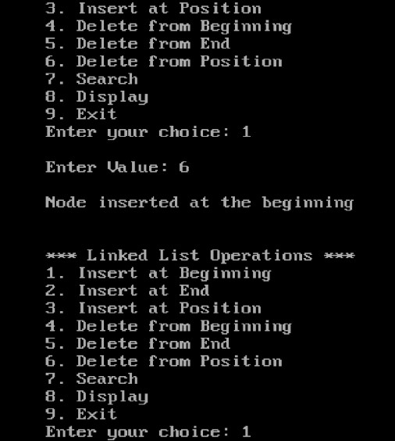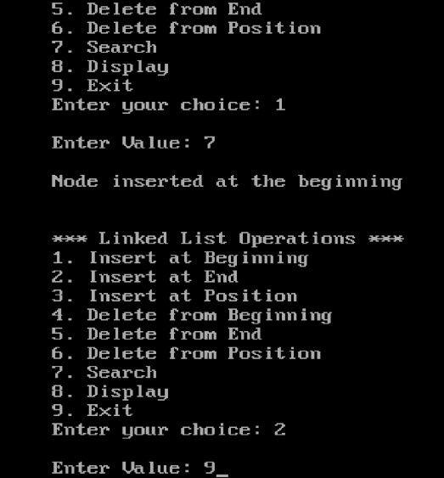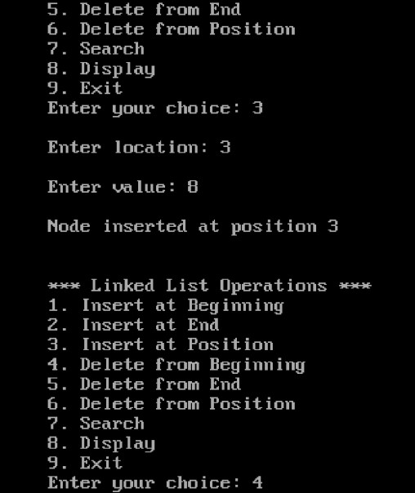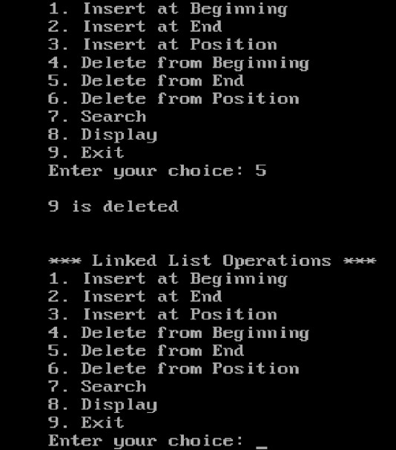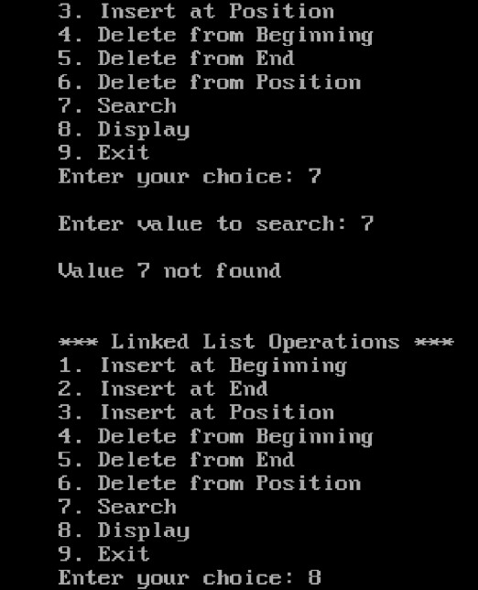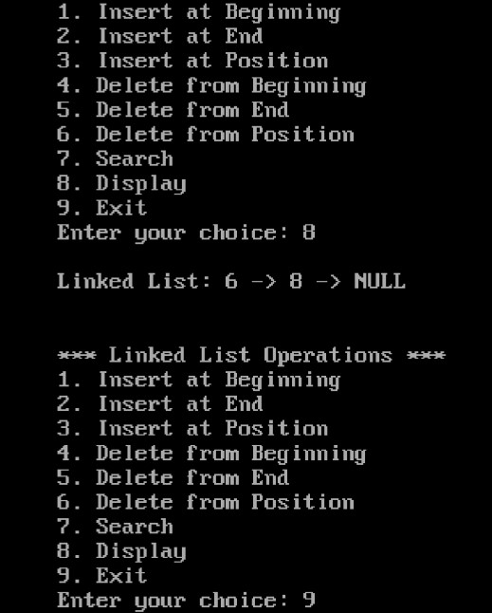

Write programs to implement the following data structures: (b) Double Linked list.

#include <stdio.h>

#include <stdlib.h>

struct Node

{ int data; struct Node* prev;

struct Node* next;

};

struct Node* head = NULL; struct Node* ptr; struct Node*temp, *temp1;

int val, flag=0, i=0, loc, pos;

void insert_begin(); void insert_last(); void insert_position(); void delete_begin(); void delete_last(); void delete_position(); void search();

void display();

void main()

{

int choice;

while (1)

{

printf("\n\n*** Doubly Linked List Operations ***\n");

printf("1. Insert at Beginning\n"); printf("2. Insert at End\n"); printf("3. Insert at Position\n"); printf("4. Delete from Beginning\n"); printf("5. Delete from End\n"); printf("6. Delete from Position\n"); printf("7. Search\n"); printf("8. Display\n"); printf("9. Exit\n"); printf("Enter your choice: ");

scanf("%d", &choice);

switch (choice)

{

case 1: insert_begin(); break; case 2: insert_last(); break; case 3: insert_position(); break; case 4: delete_begin(); break; case 5: delete_last(); break; case 6: delete_position(); break; case 7: search(); break; case 8: display(); break; case 9: exit(0); break;

default: printf("Invalid choice, please try again\n");

}

}

}

void insert_begin()

{

ptr = (struct Node*) malloc(sizeof(struct Node));

if (ptr == NULL)

{

printf("Memory is not allocated\n");

}

else

{

printf("\nEnter Value: "); scanf("%d", &val);

if (head == NULL)

{

ptr->data = val; ptr->prev = NULL;

|  |  |
| --- | --- |
|  | ptr->next = NULL; |
| } | head = ptr; |
|  | else |
|  | { |
|  | ptr->data = val; |
|  | ptr->prev = NULL; |
|  | ptr->next = head; |
|  | head->prev = ptr; |
|  | head = ptr; |
|  | } |
| } |  |

printf("\nNode inserted at the beginning\n");

}

void insert_last()

{ ptr = (struct Node*) malloc(sizeof(struct Node));

if (ptr == NULL)

{

printf("Memory is not allocated\n");

} else

{

printf("\nEnter Value: "); scanf("%d", &val);

if (head == NULL)

{

ptr->data = val; ptr->next = NULL; ptr->prev = NULL; head = ptr;

}

else

{

temp = head; while (temp->next != NULL)

{

temp = temp->next;

}

ptr->data = val;

ptr->next = NULL; temp->next = ptr;

ptr->prev = temp;

}

}

printf("\nNode inserted at the end\n");

}

void insert_position()

{

ptr = (struct Node*) malloc(sizeof(struct Node));

if (ptr == NULL)

{

printf("\nMemory is not Allocated\n");

}

else

{

printf("\nEnter location: "); scanf("%d", &pos); temp = head; for (i = 0; i < pos ; i++)

{

if (temp == NULL)

{

printf("\nCan't Insert");

}

}

printf("\nEnter Value"); scanf("%d",&val); ptr-> data = val;

ptr->prev = temp;

ptr->next = temp->next;

temp->next = ptr;

}

printf("\nNode inserted at position %d\n", pos);

}

void delete_begin()

{

|  |  |
| --- | --- |
|  | if (head == NULL) |
|  | { |
| } | printf("Doubly Linked List is empty\n"); |
|  | else |
|  | { |
|  | temp = head; |
|  | printf("\n%d is deleted\n", head->data); |
|  | head = head->next; |
|  | head->prev = NULL; |
|  | temp->next = NULL; |
|  | free(temp); |
| }  } |  |

void delete_last()

{

if (head == NULL)

{

printf("Doubly Linked List is empty\n");

}

else

{

temp = head;

while (temp->next != NULL)

{

temp = temp->next;

}

printf("\n%d is deleted\n", temp->data); temp->prev->next = NULL;

temp->prev=NULL; free(temp);

}

}

void delete_position()

{

if (head == NULL)

{

printf("Doubly Linked List is empty\n");

}

else

{

temp=head; printf("\nEnter Position: "); scanf("%d", &pos);

for (i = 0; i < pos; i++)

{

temp = temp->next; if (temp == NULL)

{

printf("\n Can't Delete");

}

}

printf("\n%d is deleted\n", temp->data); temp->prev->next = temp->next; temp->next->prev = temp->prev; temp->next =NULL; temp->prev =NULL;

free(temp);

}

}

void search()

{

if (head == NULL)

{

printf("Doubly Linked List is empty\n");

} else

{

printf("\nEnter value to search: "); scanf("%d", &val); temp = head;

while (temp != NULL)

{

if (temp->data == val)

{

printf("\n%d found at location %d\n", val, i); flag = 1;

break;

} i++;

temp = temp->next;

} if (!flag)

{ printf("\nValue %d not found\n", val);

}

}

}

void display()

|  |  |
| --- | --- |
| { |  |
|  | if (head == NULL) |
|  | { |
| } | printf("Doubly Linked List is empty\n"); |
|  | else |
|  | { |
|  | temp = head; |
|  | printf("\nDoubly Linked List: "); |
|  | while (temp != NULL) |
|  | { |

printf("%d <-> ", temp->data);

temp = temp->next;

}

printf("NULL\n");

}

}

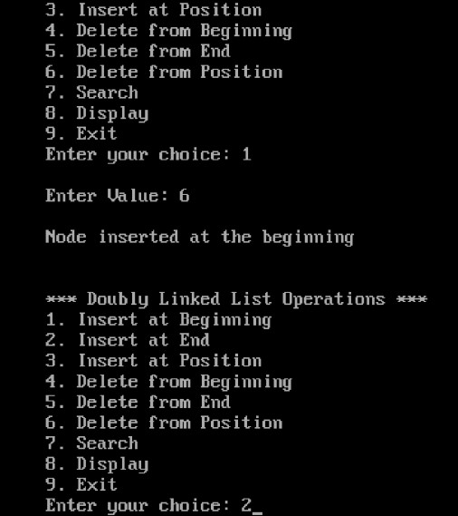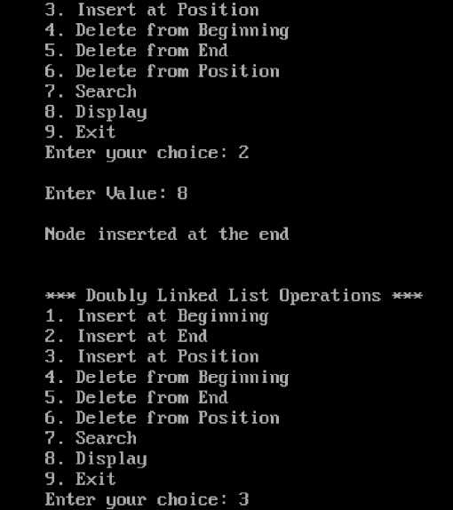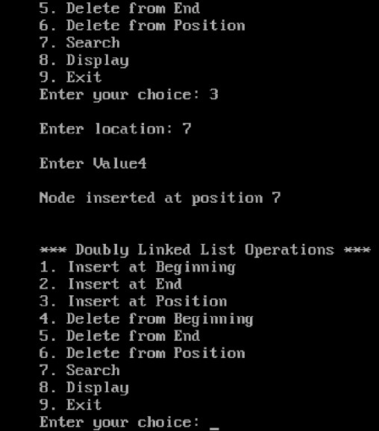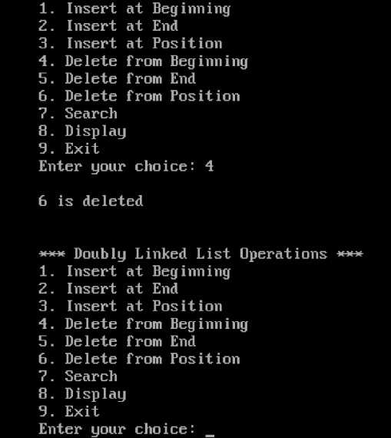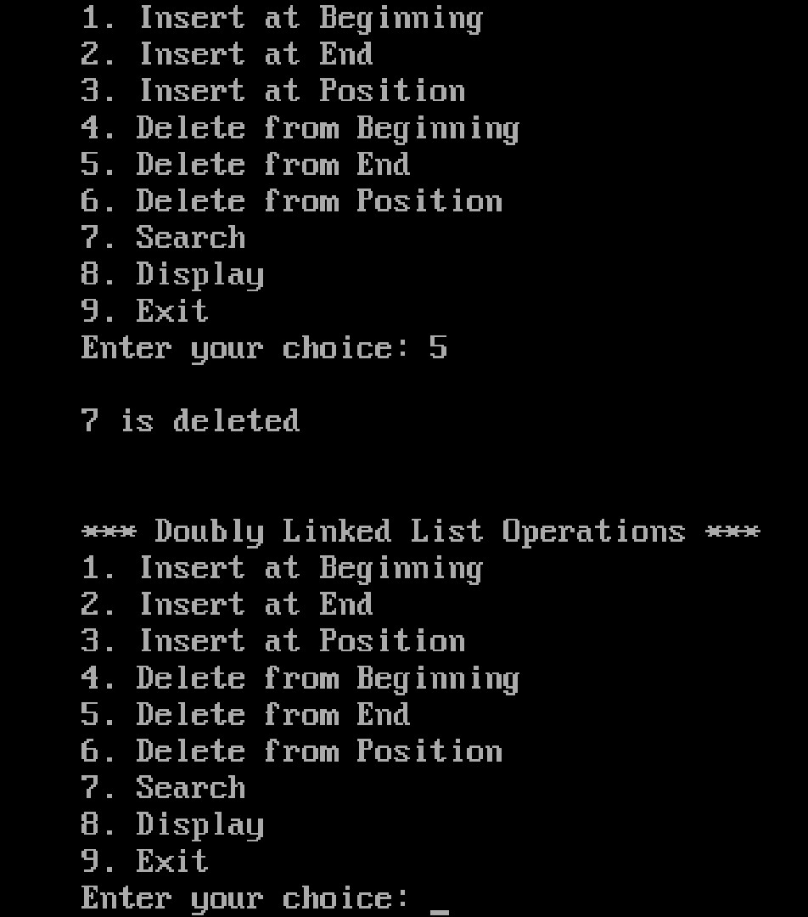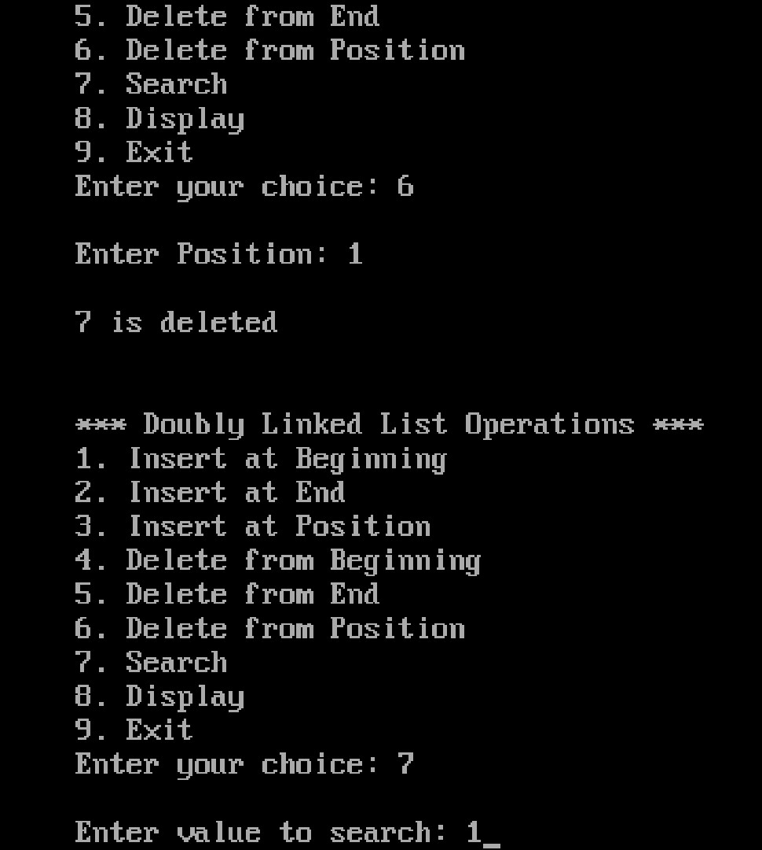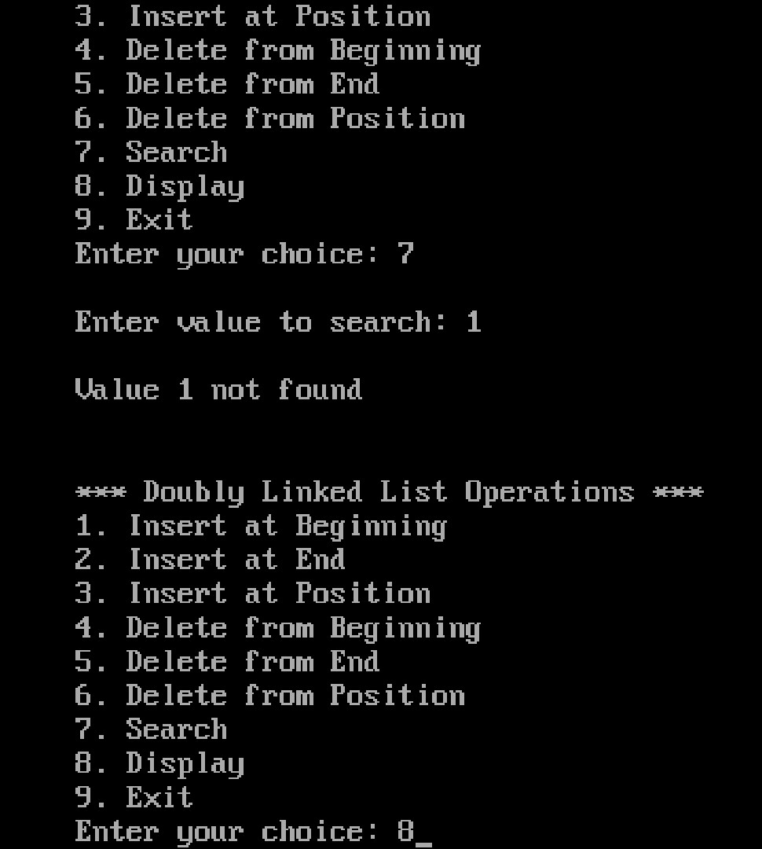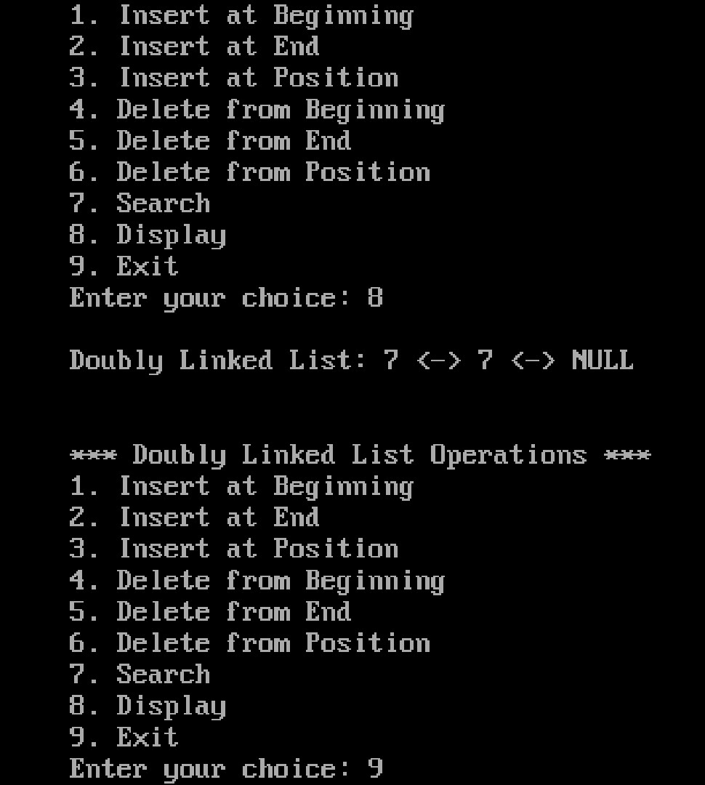

**Write a program to implement the Circular Singly linked list**

#include <stdio.h>

#include <stdlib.h>

struct Node

{ int data;

struct Node* next;

};

struct Node* head = NULL; struct Node* ptr, *temp, *temp1; int val,i,pos,flag=0;

void insert_begin(); void insert_last(); void insert_position(); void delete_begin(); void delete_last(); void delete_position(); void search();

void display();

void main()

{ int choice;

while (1) {

printf("\n\n1. Insert at Beginning\n"); printf("2. Insert at End\n"); printf("3. Insert at Position\n"); printf("4. Delete from Beginning\n"); printf("5. Delete from End\n"); printf("6. Delete from Position\n"); printf("7. Search\n"); printf("8. Display\n"); printf("9. Exit\n"); printf("Enter your choice: "); scanf("%d", &choice); switch (choice) { case 1: insert_begin(); break; case 2: insert_last(); break; case 3: insert_position(); break; case 4: delete_begin(); break; case 5: delete_last(); break; case 6: delete_position(); break; case 7: search(); break;

|  |  |  |
| --- | --- | --- |
|  |  | case 8: display(); break; |
|  |  | case 9: exit(0); break; |
|  |  | default: printf("Invalid choice, please try again\n"); |
| }  } | } |  |

void insert_begin()

{

ptr = (struct Node*) malloc(sizeof(struct Node)); if (ptr == NULL) { printf("Memory is not allocated\n");

} else {

printf("\nEnter Value: "); scanf("%d", &val); if (head == NULL)

{ ptr->data = val; head = ptr; ptr->next = head;

} else { temp = head; while (temp->next != head)

{ temp = temp->next;

}

ptr->data = val; ptr->next = head; head = ptr; temp->next = ptr;

}

printf("\nNode inserted at the beginning\n");

}

}

void insert_last()

{

ptr = (struct Node*) malloc(sizeof(struct Node)); if (ptr == NULL) { printf("Memory is not allocated\n");

} else {

printf("\nEnter Value: "); scanf("%d", &val);

|  |  |  |
| --- | --- | --- |
|  | if (head == NULL) | |
|  | { |  |
|  |  | ptr->data = val; |
|  |  | head = ptr; |
|  |  | ptr->next = ptr; |
|  | } |  |
|  | else |  |
|  | { |  |
|  |  | temp = head; |
|  |  | while (temp->next != head) |
|  |  | { |
|  |  | temp = temp->next; |
|  |  | } |
|  |  | ptr->data = val; |
|  |  | temp->next = ptr; |
|  |  | ptr->next = head; |
|  | } |  |
| }  } | printf("\nNode inserted at the end\n"); | |

void insert_position()

{ int i, pos, val; printf("\nEnter location: "); scanf("%d", &pos);

ptr = (struct Node*) malloc(sizeof(struct Node)); if (ptr == NULL) { printf("\nMemory is not Allocated\n");

} else {

printf("\nEnter value: "); scanf("%d", &val); ptr->data = val;

if (pos == 1) { ptr->next = head; head = ptr; } else { temp = head;

for (i = 1; i < pos - 1; i++)

{

temp = temp->next;

} if (temp == NULL)

{

printf("\nCan't Insert");

} else {

ptr->next = temp->next; temp->next = ptr;

printf("\nNode inserted at position %d\n", pos);

}

}

}

}

void delete_begin()

{

if (head == NULL)

{

printf("Circular Linked List is empty\n");

} else { temp = head; while (temp->next != head)

{ temp = temp->next;

}

printf("\n%d is deleted\n", head->data); temp1 = head; head = head->next; temp->next = head; temp1->next = NULL; free(temp1);

}

}

void delete_last()

{

if (head == NULL)

{

printf("Circular Linked List is empty\n");

}

else { temp = head; while (temp->next!= head)

{ temp1 = temp; temp = temp->next;

}

printf("\n%d is deleted\n", temp->data); temp1->next = head;

free(temp);

}

}

void delete_position()

{ int pos, i; if (head == NULL)

{ printf("Linked List is empty\n");

} else {

printf("\nEnter Position: "); scanf("%d", &pos); temp = head; if (pos == 1) {

printf("\n%d is deleted\n", head->data); head = head->next; free(temp); } else {

struct Node* temp1;

for (i = 1; i < pos-1; i++)

{

temp = temp->next;

}

if (temp == NULL) {

printf("\n Cant delete");

} else {

temp1 = temp->next; printf("\n%d is deleted\n", temp1->data); temp->next = temp1->next; free(temp1);

}

}

}

}

void search()

{ int val, i = 0, flag = 0; if (head == NULL)

{

printf("Linked List is empty\n");

} else {

printf("\nEnter value to search: ");

scanf("%d", &val); temp = head; while (temp != NULL)

{ if (temp->data == val)

{

printf("\n%d found at location %d\n", val, i + 1);

flag = 1; break; } i++;

temp = temp->next;

}

if (!flag) {

printf("\nValue %d not found\n", val);

}

}

}

void display()

{

if (head == NULL)

{

printf("Circular Linked List is empty\n");

} else { temp = head;

printf("\nCircular Linked List: ");

do {

printf("%d -> ", temp->data); temp = temp->next;

}

while (temp != head);

}

}

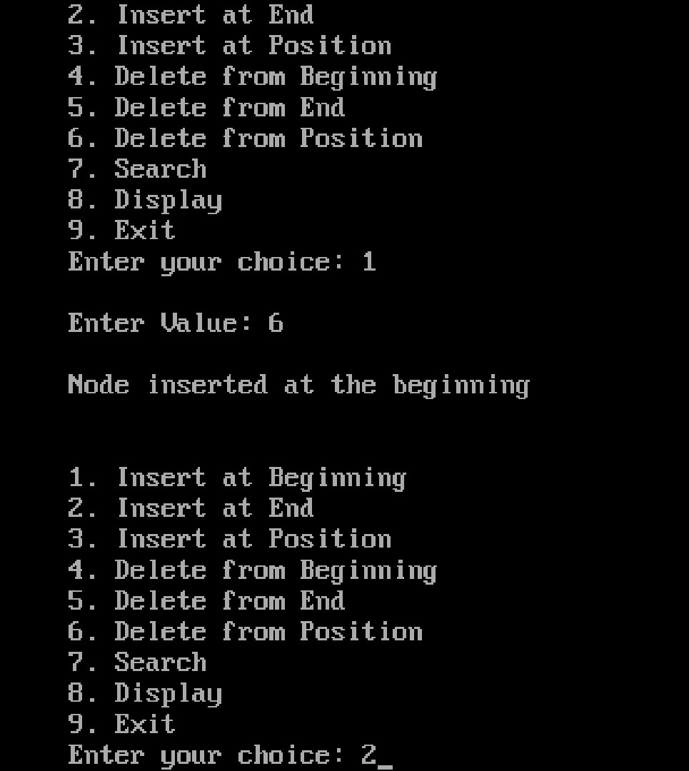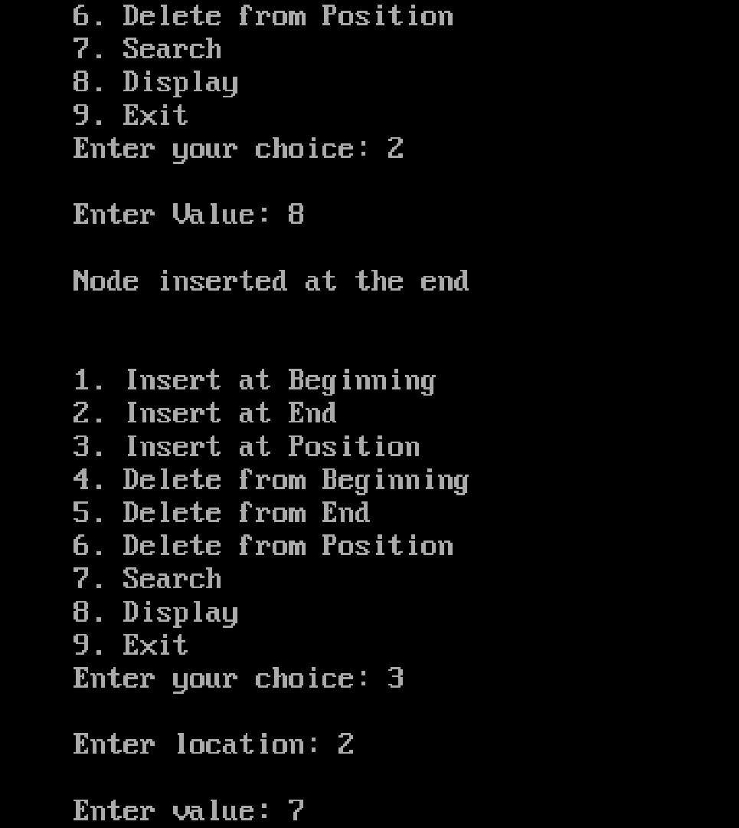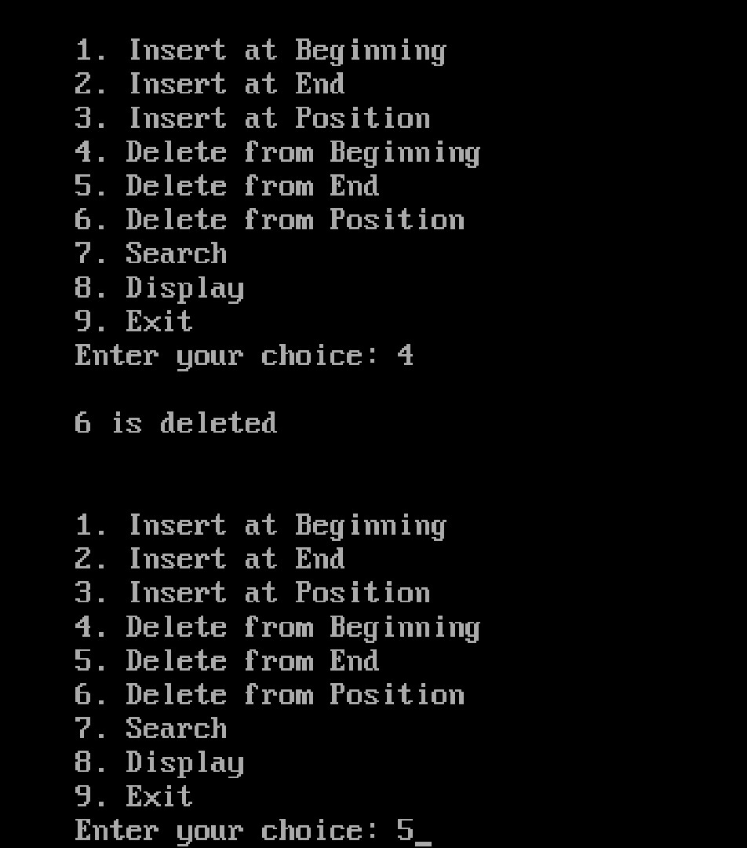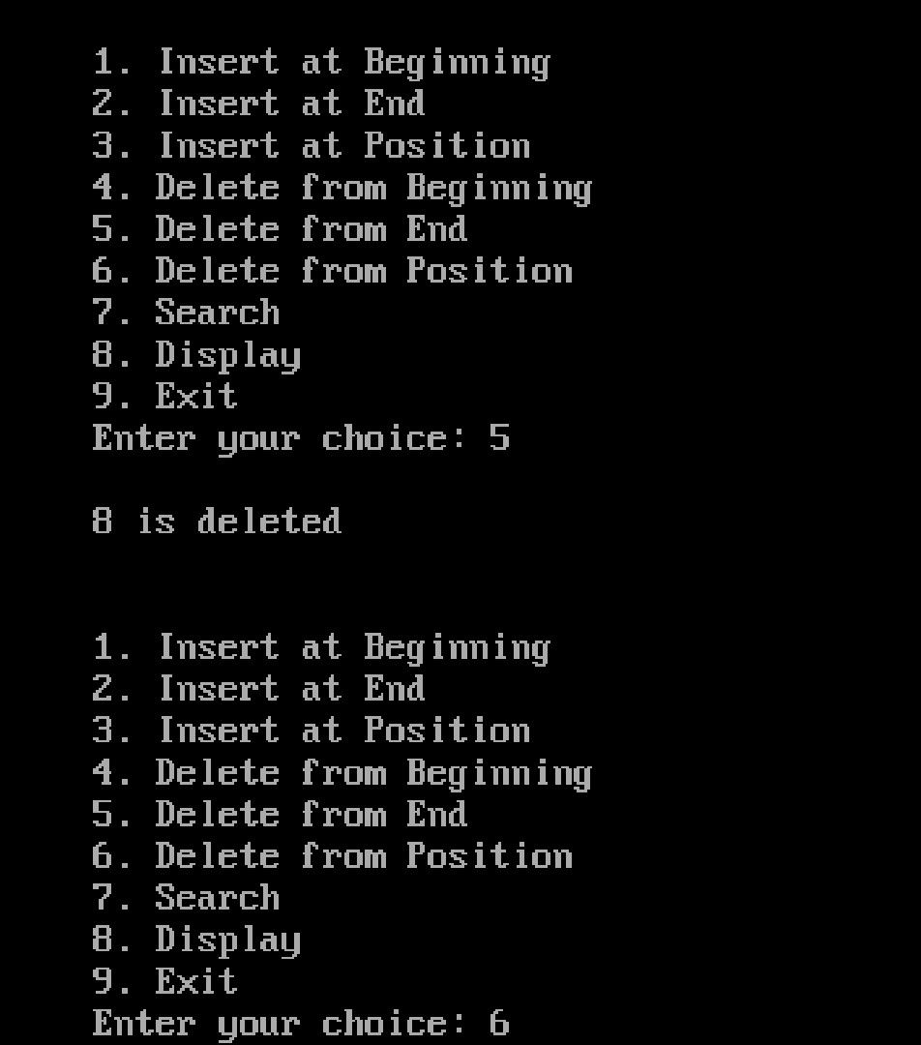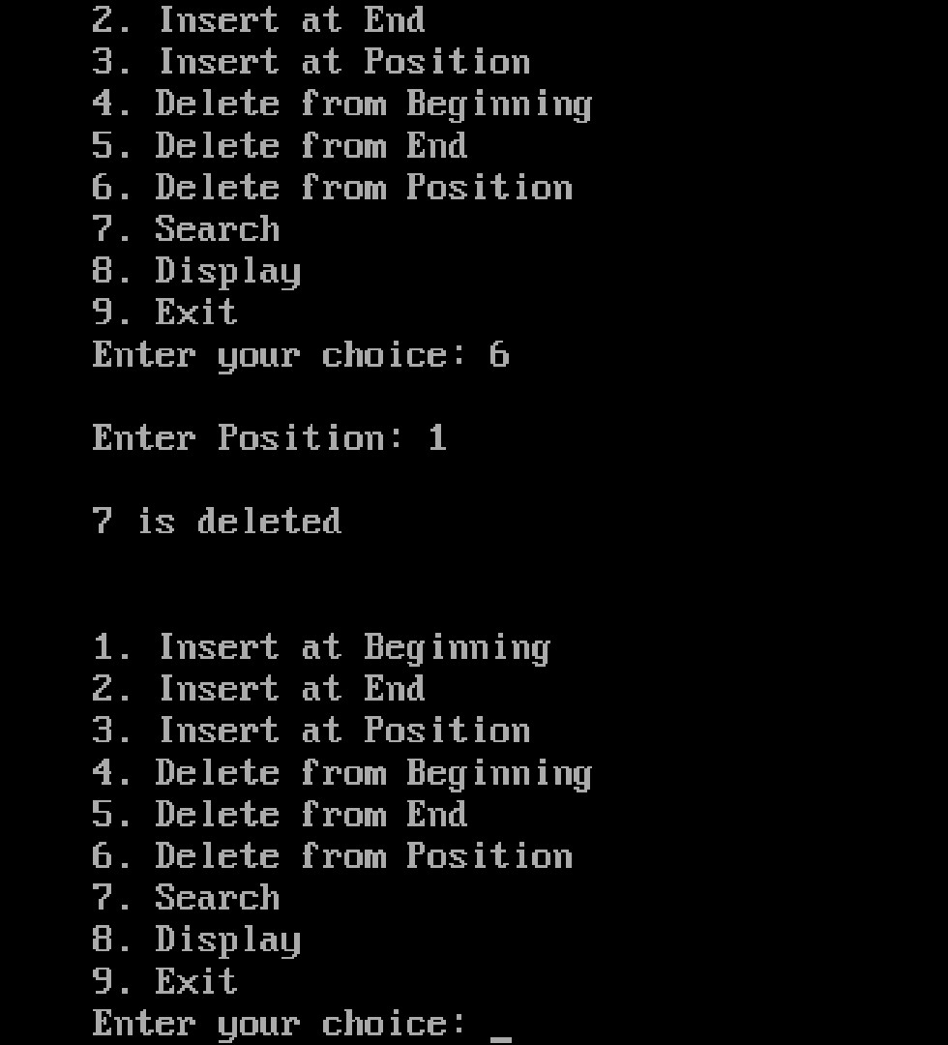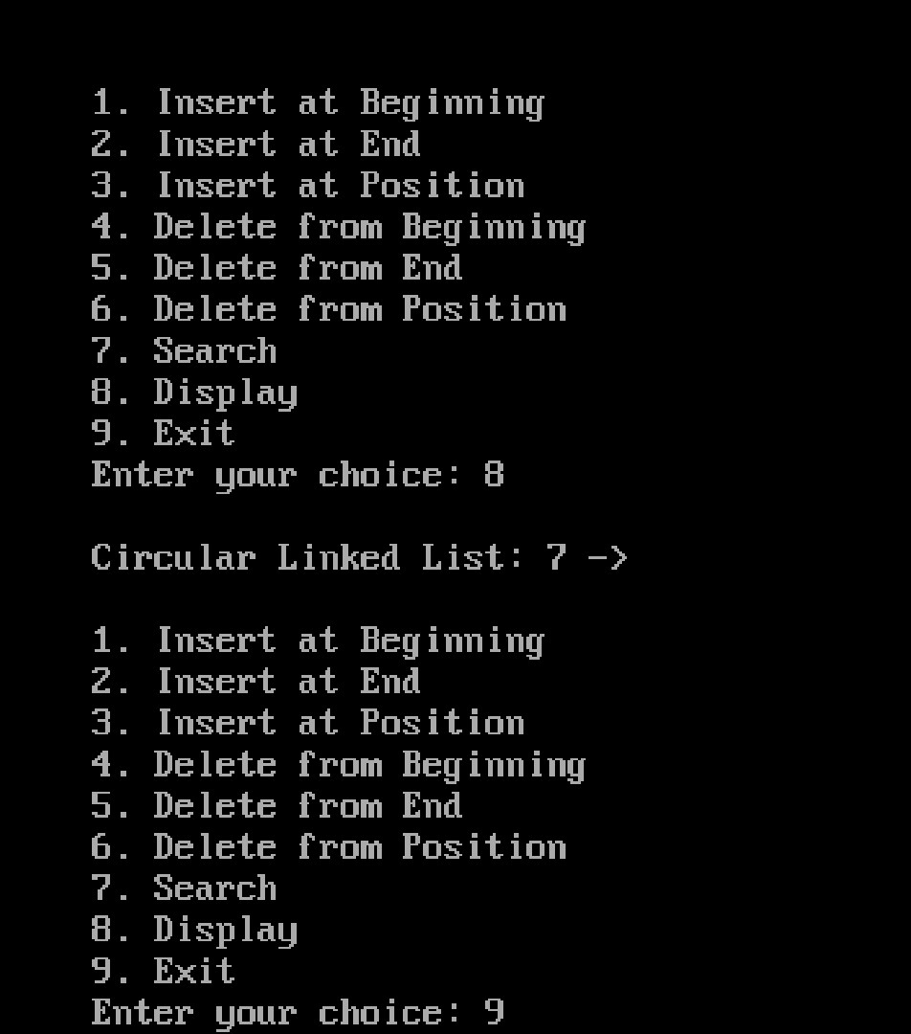

**Write a program to implement Binary Tree**.

#include<stdio.h>

#include<conio.h> #include<stdlib.h>

struct node

{

int data; struct node *left;

struct node *right;

};

struct node *root= NULL;

**void** main()

{ int ch; while(1) {

printf(“1. Create\n 2. Inorder\n 3. Preorder\n 4. Postorder\n 5. Exit”); printf(“\n Enter your choice: “);

scanf(“%d”,&ch); switch(ch)

{

|  |  |
| --- | --- |
|  | case 1: root = create(); |
|  | break; |
|  | case 2: inorder(root); |
|  | break; |
|  | case 3: preorder(root); |
|  | break; |
|  | case 4: postorder(root); |
|  | break; |
|  | case 5: exit(0); |
|  | break; |
|  | default: printf(“\n Wrong Choice:”); |
| }  }  } |  |

**struct** node *create()

{

**struct** node *temp; **int** data;

temp = (**struct** node *)malloc(**sizeof**(**struct** node)); printf("Press 0 to exit"); printf("\n Press 1 for new node"); printf("Enter your choice : "); scanf("%d", &choice);

**if**(choice==0) {  **return** 0; }  **else**

{

printf("Enter the data:"); scanf("%d", &data); temp->data = data; printf("Enter the left child of %d", data); temp->left = create(); printf("Enter the right child of %d", data); temp->right = create();

**return** temp;

}

}

void pre_order_traversal(struct node* root)

{

if(root != NULL)

{

printf("%d ",root->data); pre_order_traversal(root->leftChild);

pre_order_traversal(root->rightChild);

}

}

void inorder_traversal(struct node* root)

{

if(root != NULL) {

inorder_traversal(root->leftChild); printf("%d ",root->data); inorder_traversal(root->rightChild);

}

}

void post_order_traversal(struct node* root)

{

if(root != NULL)

{

post_order_traversal(root->leftChild); post_order_traversal(root->rightChild); printf("%d ", root->data);

}

}

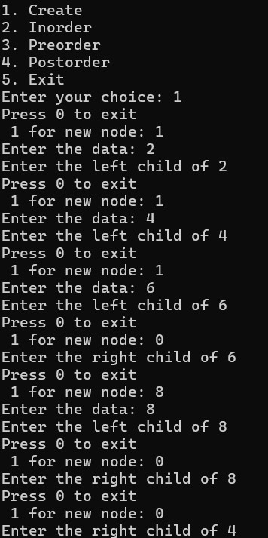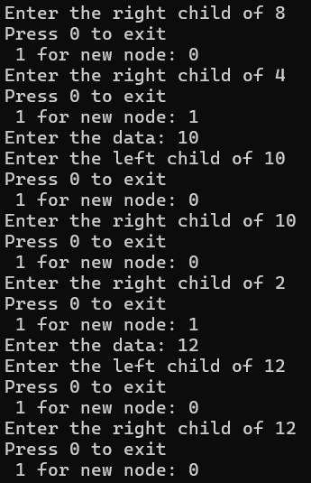

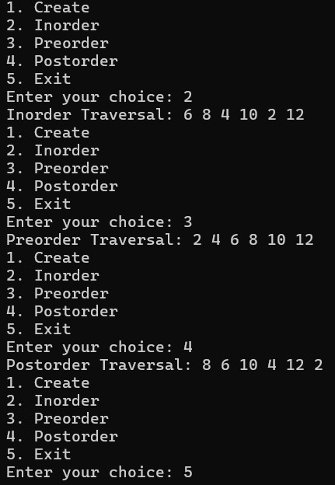

**Write a program to create a binary search tree (BST)**

#include<stdio.h>

#include<conio.h> #include<stdlib.h> struct node

{ int data;

struct node *left, *right;

};

struct node *createtree(struct node *root, int data); void search(struct node *root); void findmax(struct node *root); struct node *delet(struct node *root, int data); struct node *findmin(struct node *root); void preorder(struct node *root); void inorder(struct node *root); void postorder(struct node *root); struct node *root = NULL; void main()

{

struct node *temp;

int data, ch, i, n; while(1)

{

printf("\n1.Insertion in Binary Search Tree"); printf("\n2.Search Element in Binary Search Tree"); printf("\n3.Delete Element in Binary Search Tree"); printf("\n4.Inorder\n5.Preorder\n6.Postorder\n7.Find Min\n8.Find Max\n9.Exit"); printf("\nEnter your choice: "); scanf("%d",&ch);

switch (ch)

{

case 1: printf("\nEnter how many nodes u want to insert: " ); scanf("%d", &n); printf("\n enter values: "); for(i=0; i<n; i++)

{ scanf("%d", &data); root=createtree(root, data);

} break; case 2: search(root); break;

case 3: printf("\nEnter the element to delete: ");

scanf("%d", &data); root=delet(root, data); break;

case 4: printf("\nInorder Traversal: \n"); inorder(root); break;

case 5: printf("\nPreorder Traversal: \n");

preorder(root); break;

case 6: printf("\nPostorder Traversal: \n");

|  |  |
| --- | --- |
|  | postorder(root); |
|  | break; |
|  | case 7: temp=findmin(root); |
|  | printf("\n %d is minimum no in BST",temp->data); |
|  | break; |
|  | case 8: findmax(root); |
|  | break; |
|  | case 9: exit(0); |
|  | default: printf("WRONG CHOICE"); |
|  | break; |
|  | } |
| }  } |  |

struct node *createtree(struct node *root, int data)

{

if (root == NULL) {

struct node *temp;

temp= (struct node*)malloc(sizeof(struct node));

temp->data = data; temp->left = NULL; temp->right = NULL;

return(temp);

}

if (data < (root->data))

{ root->left = createtree(root->left, data);

}

else if (data > root->data)

{

root->right = createtree(root->right, data);

}

return root;

}

void preorder(struct node *root)

{

if(root != NULL)

{

printf("%d ",root->data); preorder(root->left);

preorder(root->right);

}

}

void inorder(struct node *root)

{

if(root != NULL)

{

inorder(root->left); printf("%d ",root->data);

inorder(root->right);

}

}

void postorder(struct node *root)

{

if(root != NULL)

|  |  |  |
| --- | --- | --- |
|  | { |  |
|  |  | postorder(root->left); |
|  |  | postorder(root->right); |
|  |  | printf("%d ", root->data); |
| } | } |  |

struct node *delet(struct node *root, int data)

{

struct node *temp;

if(root == NULL)

{

printf("\nElement not found");

}

else if(data < root->data)

{

root->left = delet(root->left, data);

}

else if(data > root->data)

{

root->right = delet(root->right, data);

} else

{

if(root->right && root->left)

{

temp = findmin(root->right); root->data = temp->data;

root->right = delet(root->right,temp->data);

} else

{

temp = root; if(root->left == NULL) root = root->right; else if(root->right == NULL) root = root->left;

free(temp); /* temp is longer required */

}

}

return root;

} struct node *findmin(struct node *root)

{ struct node *temp; temp = root; if(temp==NULL) { return NULL; }

if(temp->left) return findmin(temp->left);

else return temp;

}

void findmax(struct node *root)

{

if(root==NULL)

{

return;

}

if(root->right) findmax(root->right); else printf("\n %d is maximum no in BST",root->data);

}

void search(struct node *root)

{

int data; if(root == NULL)

{

printf("\nBST is empty.");

return;

}

printf("\nEnter Element to be searched: ");

scanf("%d", &data); while(root != NULL)

{ if (root->data == data)

{

printf("\nKey element is present in BST"); return;

}

if (data < root->data) root = root->left; else root = root->right;

} printf("\nKey element is not found in the BST");

}

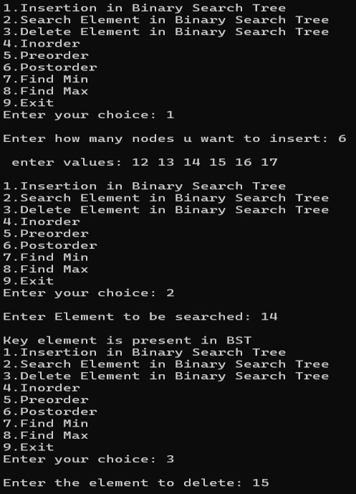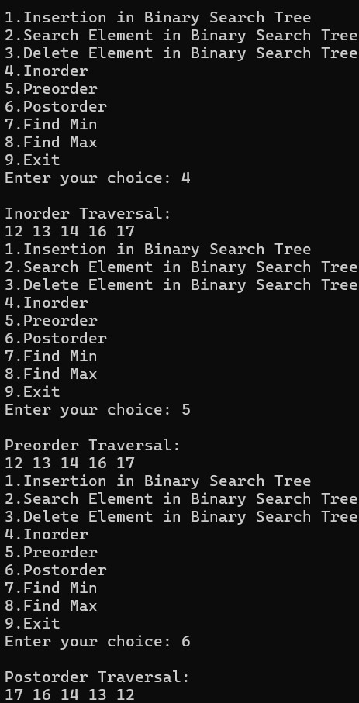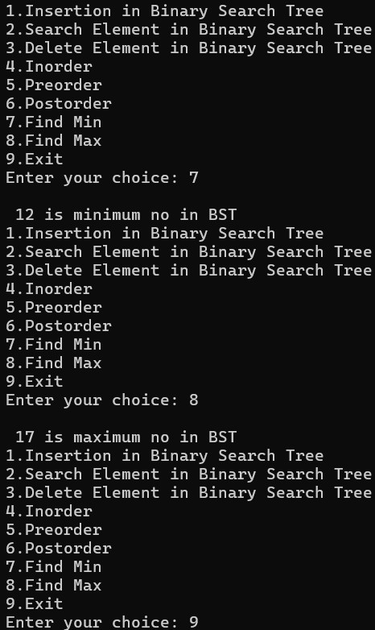

**Write programs for implementation of graph traversals by applying: (a) BFS (b) DFS**

#include<stdio.h> int q[20],top=-1,front=-1,rear=-1,a[20][20],vis[20],stack[20]; int delete(); void add(int item); void bfs(int s,int n); void dfs(int s,int n); void push(int item); int pop();

void main()

{

int n,i,s,ch,j; char c,dummy;

printf("ENTER THE NUMBER VERTICES "); scanf("%d",&n); for(i=1;i<=n;i++)

{

for(j=1;j<=n;j++)

{

printf("ENTER 1 IF %d HAS A NODE WITH %d ELSE 0 ",i,j); scanf("%d",&a[i][j]);

} } printf("THE ADJACENCY MATRIX IS\n"); for(i=1;i<=n;i++)

{

for(j=1;j<=n;j++)

{

printf(" %d",a[i][j]);

}

printf("\n");

}

do { for(i=1;i<=n;i++) vis[i]=0; printf("\nMENU"); printf("\n1.B.F.S"); printf("\n2.D.F.S"); printf("\nENTER YOUR CHOICE"); scanf("%d",&ch);

printf("ENTER THE SOURCE VERTEX :"); scanf("%d",&s); switch(ch) { case 1:bfs(s,n); break; case 2:dfs(s,n); break;

}

printf("DO U WANT TO CONTINUE(Y/N) ? "); scanf("%c",&dummy); scanf(" %c",&c); // Added space before %c

}while((c=='y')||(c=='Y'));

}

void bfs(int s,int n)

{

int p,i; add(s); vis[s]=1; p=delete(); if(p!=0) printf(" %d",p); while(p!=0) { for(i=1;i<=n;i++) if((a[p][i]!=0)&&(vis[i]==0))

{ add(i); vis[i]=1; } p=delete(); if(p!=0) printf(" %d ",p);

} for(i=1;i<=n;i++) if(vis[i]==0) bfs(i,n);

}

void add(int item)

{ if(rear==19) printf("QUEUE FULL"); else { if(rear==-1)

{ q[++rear]=item; front++; } else q[++rear]=item;

}

}

int delete()

{

int k; if((front>rear)||(front==-1)) return(0); else { k=q[front++]; return(k);

}

}

void dfs(int s,int n) { int i,k; push(s); vis[s]=1; k=pop(); if(k!=0) printf(" %d ",k); while(k!=0)

{

|  |  |  |
| --- | --- | --- |
|  | for(i=1;i<=n;i++) | |
|  |  | if((a[k][i]!=0)&&(vis[i]==0)) |
|  |  | { |
|  |  | push(i); |
|  |  | vis[i]=1; |
|  |  | } |
|  |  | k=pop(); |
|  |  | if(k!=0) |
| } |  | printf(" %d ",k); |

for(i=1;i<=n;i++) if(vis[i]==0) dfs(i,n);

}

void push(int item)

{

if(top==19) printf("Stack overflow "); else stack[++top]=item;

} int pop() { int k; if(top==-1) return(0); else {

k=stack[top--]; return(k);

}

}

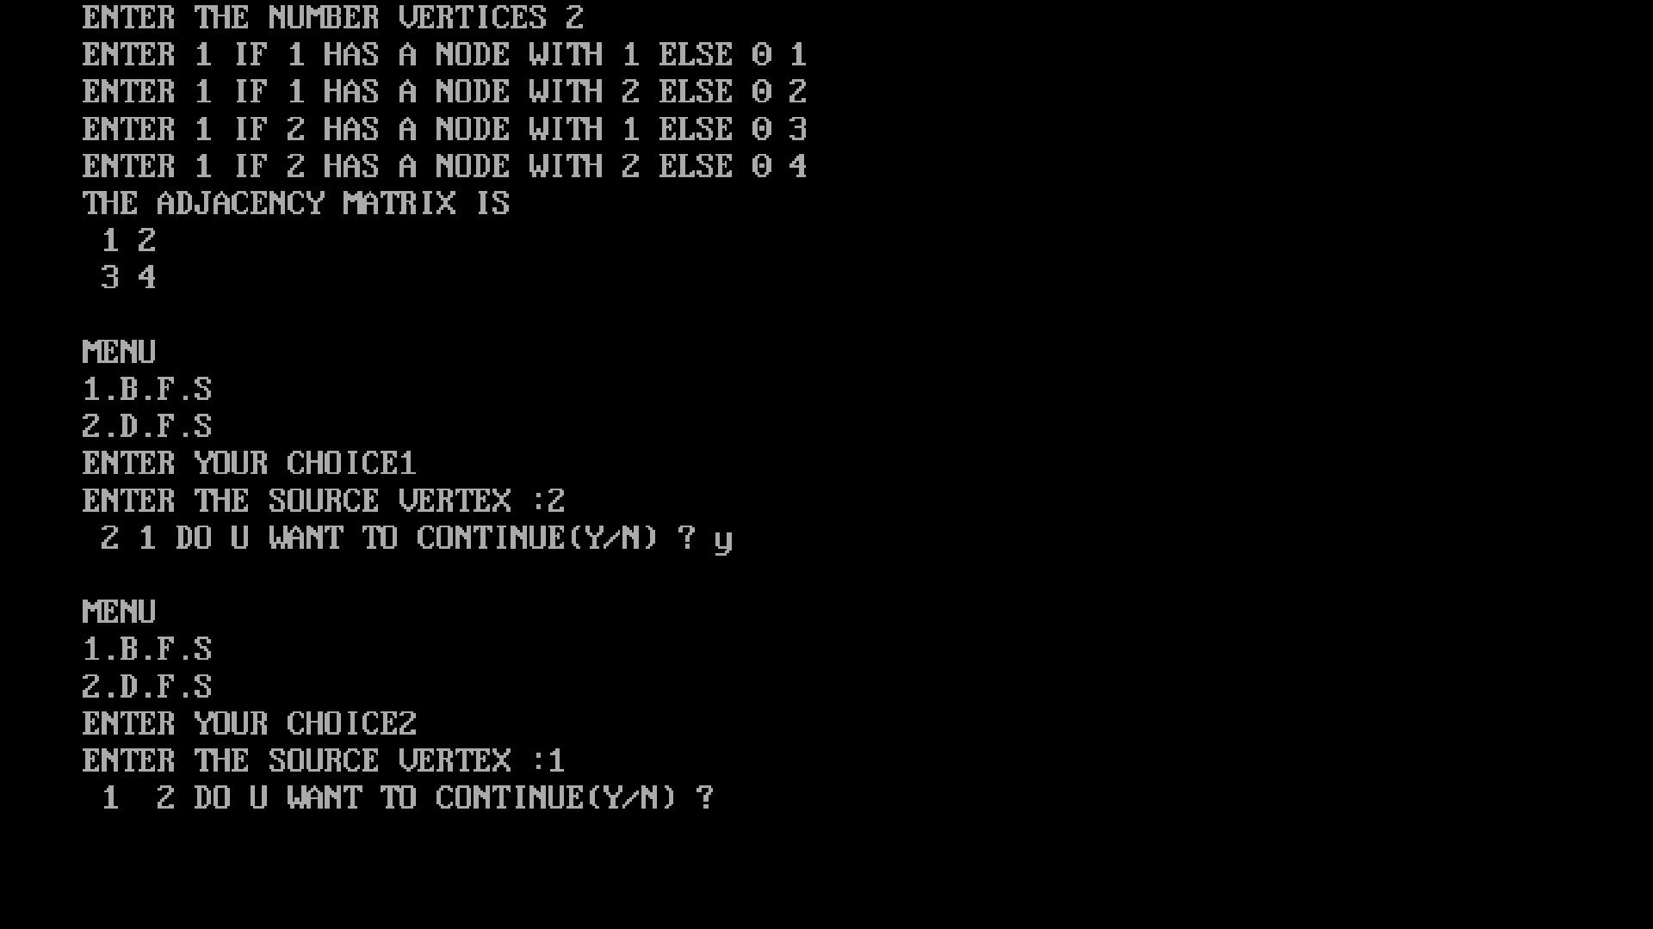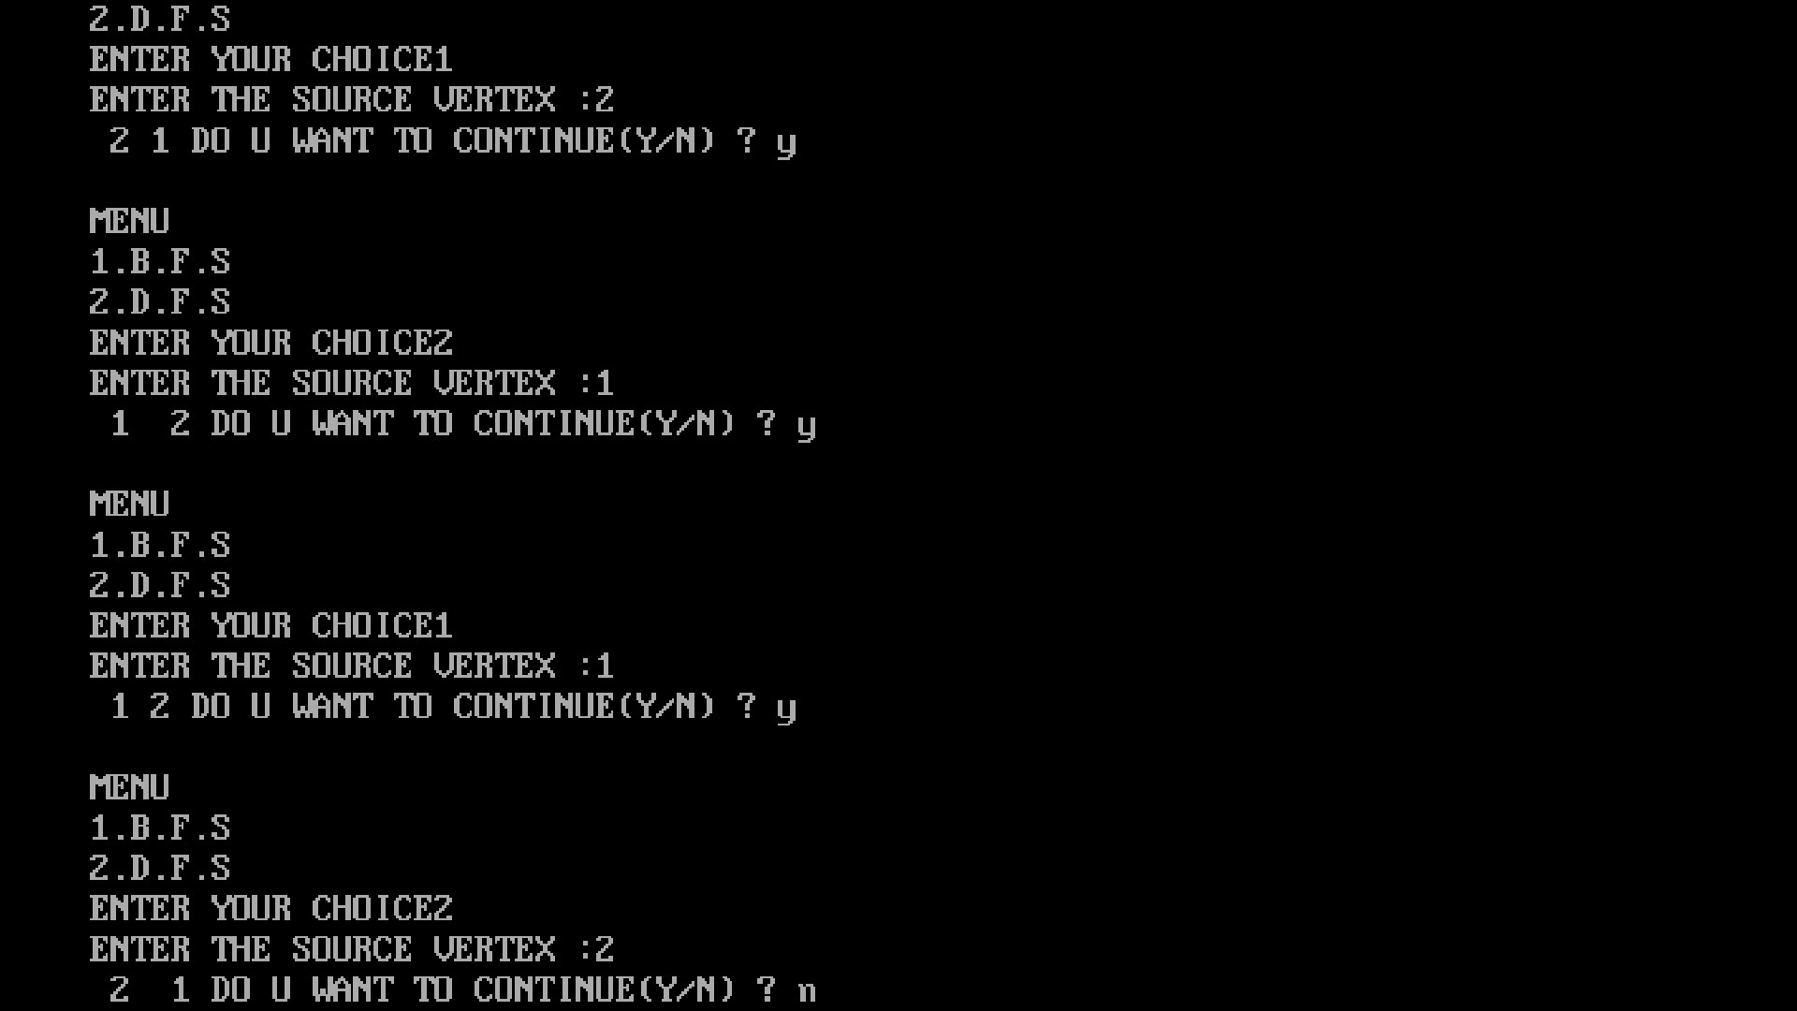

**Implement the following sorting algorithms:**

**(a) Insertion sort**

#include <stdio.h>

#include <conio.h> // Required for clrscr() and getch()

void insert(int a[], int n) /* function to sort an array with insertion sort */

{

int i, j, temp; for (i = 1; i < n; i++)

{

temp = a[i]; j = i - 1;

while (j >= 0 && temp <= a[j])

{ a[j + 1] = a[j]; j = j - 1; } a[j + 1] = temp;

}

}

void printArr(int a[], int n) /* function to print the array */

{ int i; for (i = 0; i < n; i++) printf("%d ", a[i]);

}

void main()

{

int a[50]; // Fixed size array for Turbo C compatibility int n, i;

clrscr(); // Clear screen at start printf("Enter the number of elements (max 50): "); scanf("%d", &n);

if (n > 50)

{

printf("Number of elements should not exceed 50."); getch(); // Wait for key press before exit return;

}

printf("Enter the elements:\n"); for (i = 0; i < n; i++)

{

scanf("%d", &a[i]);

}

printf("Before sorting, array elements are - \n"); printArr(a, n); insert(a, n); printf("\nAfter sorting, array elements are - \n"); printArr(a, n);

getch(); // Wait for key press before closing

}

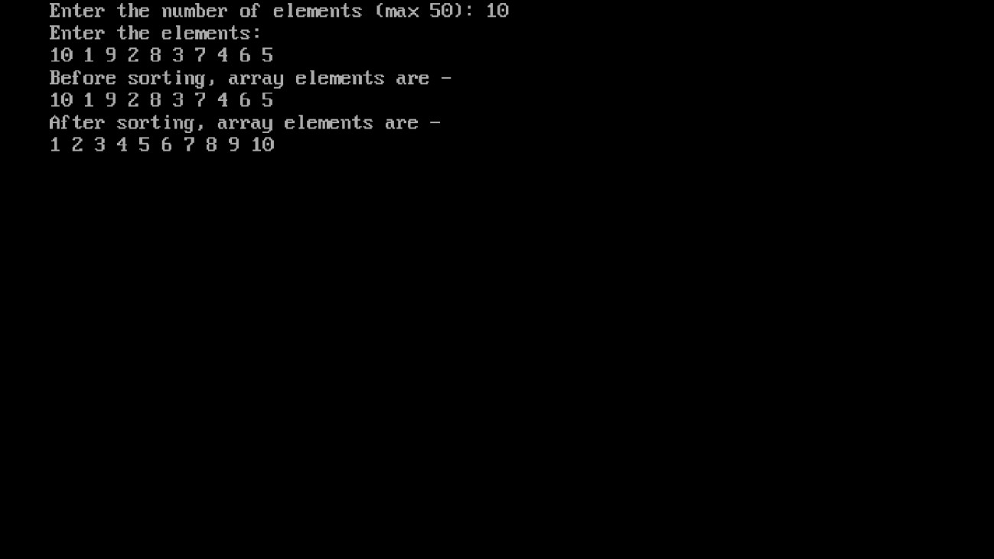

**Implement the following sorting algorithms:**

**(b) Selection Sort**

#include<stdio.h>

#include<conio.h> #include<stdlib.h> void selection_sort(int a[],int n); void display(int a[], int n); int a[10], n; void main() { int i,ch; clrscr(); printf("\n enter how many elements u want to insert: "); scanf("%d",&n); printf("\n enter the elements: "); for(i=0;i<n;i++) {

scanf("%d",&a[i]);

} while(1) {

printf("\n1. Sort array"); printf("\n2. display sorted array"); printf("\n3. exit"); printf("\n Enter your choice: "); scanf("%d", &ch); switch(ch) {

case 1: selection_sort(a,n);

|  |  |  |
| --- | --- | --- |
|  |  | printf("\n array is sorted: "); |
|  |  | break; |
|  |  | case 2: display(a,n); |
|  |  | break; |
|  |  | case 3: exit(0); |
|  |  | default: printf("\n wrong choice: "); |
|  | } |  |
| }  } |  |  |

void selection_sort(int a[], int n)

{

int i,j,small, temp; for(i=0;i<n-1;i++) { small=i; for(j=i+1;j<n;j++) { if(a[j]<a[small]) { small=j;

}

}

temp=a[small]; a[small]=a[i]; a[i]=temp;

}

}

void display(int a[], int n)

{ int i; printf("\n sorted array is: "); for(i=0;i<n;i++)

{ printf("\n %d",a[i]);

}

}

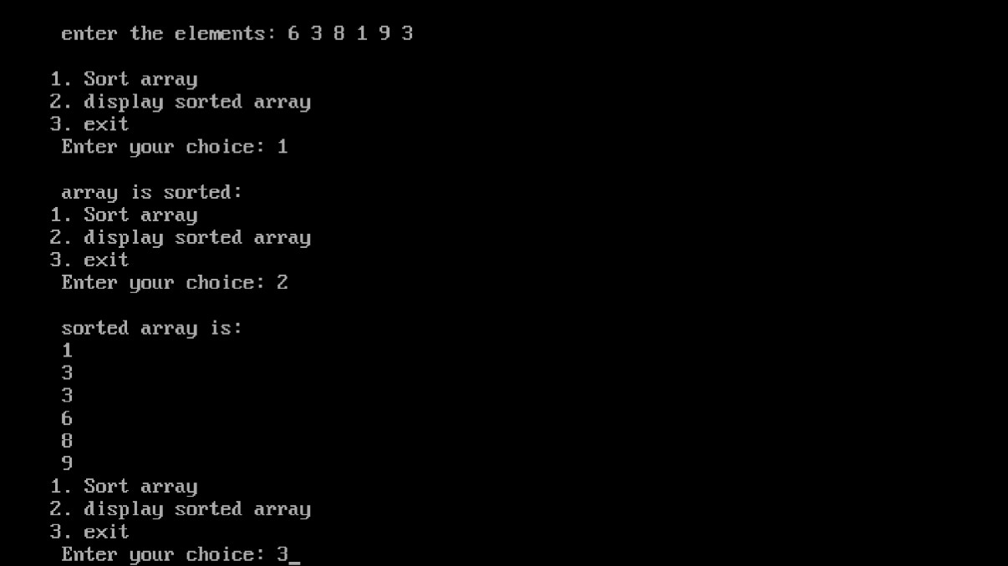

**Implement the following sorting algorithms:**

**(a) Quick sort**

#include<stdio.h>

#include<conio.h> #include<stdlib.h>

void quicksort(int a[], int first, int last); void main() {

int i,n,a[20]; clrscr(); printf("\n Enter how many elements u want to enter: "); scanf("%d",&n); printf("\n Enter the %d elemets in array: ",n); for(i=0;i<n;i++) {

scanf("%d", &a[i]);

}

quicksort(a,0,n-1); printf("\n sorted array is: "); for(i=0;i<n;i++) {

printf(" %d ",a[i]);

} getch();

}

void quicksort(int a[], int first, int last)

{

int i,j,pivot,temp; if(first<last)

{ pivot=first; i=first; j=last; while(i<j) {

while(a[i]<=a[pivot] && i<last)

{ i++;

}

while(a[j]>a[pivot])

{

j--;

}

if(i<j)

{

temp=a[i]; a[i]=a[j]; a[j]=temp;

}

} temp=a[pivot]; a[pivot]=a[j]; a[j]=temp; quicksort(a,first,j-1); quicksort(a,j+1,last);

}

}

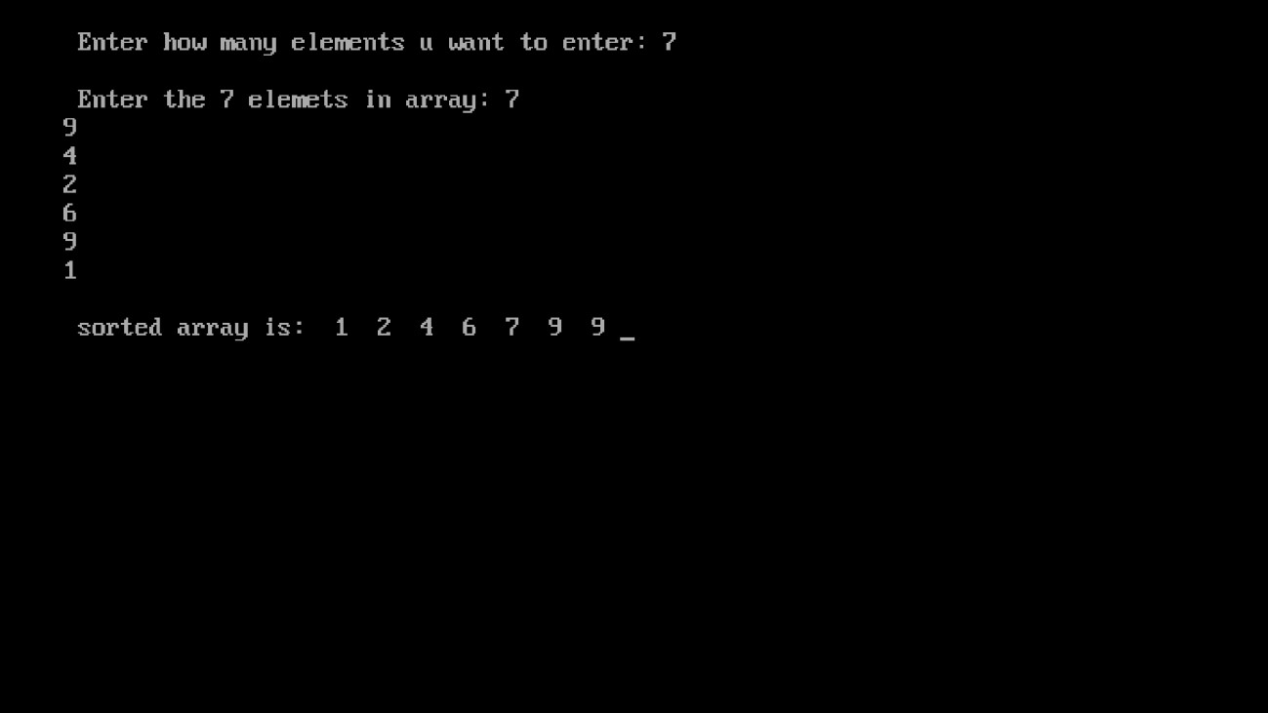

**Implement the following sorting algorithms:**

**(b) Merge sort**

#include<stdio.h> #include<conio.h>

void mergesort(int a[], int lb, int ub); void merge(int a[], int lb, int mid, int ub); void main() {

int i,n,a[20]; clrscr(); printf("\n Enter how many elements u want to enter: "); scanf("%d",&n); printf("\n Enter the %d elemets in array: ",n); for(i=0;i<n;i++)

{

scanf("%d", &a[i]);

}

mergesort(a,0,n-1); printf("\n sorted array is: "); for(i=0;i<n;i++)

{

printf(" %d ",a[i]);

} getch();

}

void mergesort(int a[], int lb, int ub)

{

int mid; if(lb<ub)

{

|  |  |  |
| --- | --- | --- |
|  |  | mid=(lb+ub)/2; |
|  |  | mergesort(a,lb,mid); |
|  |  | mergesort(a, mid+1,ub); |
|  |  | merge(a,lb,mid,ub); |
| } | } |  |

void merge(int a[], int lb, int mid, int ub)

{ int i,j,k; int b[20]; i=lb; j=mid+1; k=lb; while(i<=mid && j<=ub) { if(a[i]<=a[j])

{

b[k]=a[i]; k++; i++;

} else

{

b[k]=a[j]; j++; k++;

} } while(i<=mid) { b[k]=a[i]; i++;

k++; } while(j<=ub) { b[k]=a[j]; k++; j++;

}

for(k=lb;k<=ub;k++) // Changed from k=0 to k=lb

{ a[k]=b[k];

}

}

